Concrete Crack Detection Using Instance Segmentation Models
(Mask R-CNN and YOLOv26m-Seg Comparative Study)

By;
Elham Saeidi
Bernice Eghan

1. Problem Definition
Structural cracks in concrete infrastructure are critical indicators of deterioration and potential structural failure. Early detection and accurate assessment of these cracks are essential for ensuring safety, reducing maintenance costs, and extending the lifespan of civil structures. However, traditional inspection methods rely heavily on manual visual assessment, which is time-consuming, labor-intensive, and prone to human error and subjectivity.
With the advancement of computer vision and deep learning, automated crack detection systems have emerged as a promising alternative. These systems aim to accurately identify and localize cracks from images, and in more advanced cases, perform pixel-level segmentation to capture detailed crack structures. Despite this progress, detecting cracks remains a challenging task due to several inherent factors, including:
- the thin and irregular nature of cracks
- low contrast between cracks and background surfaces
- variability in lighting conditions and surface textures
- inconsistencies in annotation quality across datasets
Furthermore, different deep learning architectures exhibit varying strengths and limitations when applied to this problem. For instance, two-stage models such as Mask R-CNN are designed for accurate localization and segmentation, while one-stage models like YOLO prioritize speed and efficiency, often with competitive accuracy.
Given these differences, there is a need for a systematic evaluation and comparison of these approaches to determine their effectiveness for crack detection and segmentation tasks.
Problem Statement
“There is a need for an accurate, efficient, and reliable automated system for detecting and segmenting cracks in concrete structures. However, the performance of existing deep learning models varies significantly due to the complex nature of crack patterns and dataset limitations. This study aims to address this challenge by implementing and comparing Mask R-CNN and YOLO models to determine the most suitable approach for practical crack detection applications.”

2. Objectives
The primary objective of this study is to develop and evaluate deep learning models for automated crack detection and segmentation in concrete structures, and to compare their performance in terms of accuracy, efficiency, and robustness.

Specific Objectives
- To develop a crack detection system using deep learning techniques
Implement models capable of identifying and localizing cracks in concrete images using supervised learning approaches.
- To implement and train an instance segmentation model
Utilize Mask R-CNN to perform both object detection and pixel-level segmentation of cracks.
- To implement and train a real-time detection and segmentation model
Apply YOLO to achieve efficient crack detection and segmentation with improved speed and performance.
- To prepare and process datasets for model training
Merge, clean, and structure multiple crack datasets, ensuring compatibility with both models through appropriate annotation formats and preprocessing techniques.
- To apply training and fine-tuning strategies
Develop a staged training approach, including baseline training, fine-tuning, and controlled refinement, to optimize model performance.
- To evaluate model performance using standard metrics
Assess both models using COCO evaluation metrics, including Average Precision (AP) and Average Recall (AR) for detection and segmentation tasks.
- To compare the performance of Mask R-CNN and YOLO
Analyze and compare the models based on detection accuracy, segmentation quality, training behavior, generalization capability, computational efficiency
- To identify limitations and propose improvements
Investigate challenges encountered in crack detection and segmentation, and suggest potential enhancements for future work.

3. Scope
This study focuses on the development, training, and evaluation of deep learning models for automated crack detection and segmentation in concrete surfaces. Specifically, the work investigates and compares the performance of Mask R-CNN and YOLO within a controlled experimental setup.
The scope of the project includes:
- Detection and Segmentation Tasks:
Both bounding box detection and pixel-level segmentation are addressed. Mask R-CNN is used to explore detailed instance segmentation, while YOLO is used for efficient detection and segmentation in a unified framework.
- Dataset Preparation and Integration:
Multiple crack datasets are merged, cleaned, and structured into a unified format. The study includes data preprocessing, annotation handling, and dataset splitting for training and evaluation.
- Model Training and Fine-Tuning:
A staged training approach is implemented for both models, including baseline training, fine-tuning on improved datasets, and controlled refinement to enhance performance.
- Performance Evaluation:
Model performance is evaluated using standard COCO metrics, including Average Precision (AP) and Average Recall (AR) for both detection and segmentation tasks.
- Comparative Analysis:
The study compares the models in terms of detection accuracy, segmentation quality, training behavior, generalization, and computational efficiency.

Out of Scope
To maintain focus and feasibility, the following aspects are not addressed in this study:
- Real-time deployment in production environments
- Hardware optimization for edge or embedded systems
- 3D crack detection or multi-modal data fusion
- Extensive hyperparameter optimization beyond controlled tuning
- Large-scale industrial validation across diverse infrastructures

4. Data
The datasets were extracted from Roboflow and Kaggle and consist of labeled images of concrete surfaces with visible cracks, structured in COCO format to support instance segmentation tasks. Three set of data were used, one for the base training, one, first fine-tuning and the other, second fine-tuning

4.1 Data Preparation
Data preparation is a crucial step in ensuring the quality and effectiveness of deep learning models. In this study, a structured data preparation pipeline was implemented to support the training of both Mask R-CNN and YOLO for crack detection and segmentation.

4.1.1 Dataset Collection and Integration
The dataset used in this study was constructed by combining multiple crack image datasets obtained from different sources. These datasets varied in:
- annotation formats
- image resolutions
- labeling styles
To ensure consistency, all datasets were merged into a unified structure, forming a comprehensive dataset suitable for model training.

4.1.2 Data Cleaning
Following dataset integration, a cleaning process was carried out to improve data quality and reduce noise. This involved:
- Removal of Duplicate Images:
Duplicate or highly similar images were identified and removed to prevent bias during training.
- Consistency Checks:
Images and annotations were verified to ensure correct alignment and completeness.
- Correction of Annotation Errors:
Any inconsistencies in labels, bounding boxes, or masks were addressed to maintain annotation integrity.
This process helped ensure that the dataset was reliable and suitable for training robust models.

4.1.3 Dataset Structuring
The cleaned dataset was organized into a standard directory structure compatible with both models. This included train, test and val. Each subset contained corresponding images and annotations. For YOLO, images and labels were stored in separate directories, while for Mask R-CNN, annotations were stored in COCO JSON format.

4.1.4 Data Splitting
The dataset was divided into training, validation, and test sets to support model development and evaluation:
- Training Set: Used for model learning
- Validation Set: Used for monitoring performance and tuning
- Test Set: Used for final evaluation and generalization assessment
Care was taken to ensure that each subset contained a representative distribution of crack types and conditions.

4.1.5 Data Transformation
To prepare the data for model input, several preprocessing steps were applied:
- Image Resizing:
All images were resized to a fixed resolution (640 × 640) to ensure consistency across batches.
- Normalization:
Pixel values were scaled to a standard range to improve training stability and convergence.
- Tensor Conversion:
Images and annotations were converted into tensor format for compatibility with deep learning frameworks.

4.1.6 Format Conversion
To support both models, annotations were converted into appropriate formats:
- COCO format for Mask R-CNN
- YOLO segmentation format for YOLO
This ensured seamless integration with their respective training pipelines.

4.1.7 Multi-Stage Dataset Preparation
A staged dataset approach was used to improve model performance progressively:
- Stage 1 Dataset: Initial dataset used for baseline training (train=3755, val=804, test=804)
- Stage 2 Dataset: Cleaned and merged dataset for fine-tuning( train=3662, val=1057, test=915)
- Stage 3 Dataset: Refined dataset with enhanced segmentation focus (train=
This approach enabled gradual learning and improved model robustness.

4.2 Annotation
Accurate annotation is a critical component in supervised deep learning, particularly for tasks involving both object detection and segmentation. In this study, annotations were prepared to support the training of both Mask R-CNN and YOLO.
The datasets used in this work contained a combination of:
- bounding box annotations for object localization
- segmentation masks for pixel-level crack representation
To ensure compatibility across models, all annotations were standardized into appropriate formats:
- COCO format for Mask R-CNN
- YOLO segmentation format for YOLO

Annotation Process
The annotation workflow involved:
- Dataset Integration:
Multiple crack datasets were merged into a unified structure, requiring alignment of annotation formats and class definitions.
- Format Conversion:
Existing mask annotations were converted into COCO format, including polygon representations and bounding box extraction. For YOLO, segmentation labels were formatted into normalized polygon coordinates.
- Class Definition:
A single class label (“crack”) was used, simplifying the classification task and focusing the models on localization and segmentation accuracy.

Annotation Challenges
Several challenges were encountered due to the nature of crack data:
- Thin and Irregular Structures:
Cracks often appear as narrow, fragmented lines, making precise boundary annotation difficult.
- Inconsistent Mask Thickness:
Variations in annotation style across datasets led to differences in mask width and shape.
- Low Contrast Regions:
In some images, cracks are visually similar to the background, increasing the difficulty of accurate labeling.
These factors can introduce noise into the training process and affect segmentation performance, particularly for pixel-level evaluation metrics.

Impact on Model Performance
The quality and consistency of annotations directly influence model learning:
- Accurate annotations improve localization and segmentation performance
- Inconsistent masks reduce boundary precision
- Noisy labels can limit generalization capability
Despite these challenges, the standardized annotation pipeline enabled effective training across both models.

4.3 Data Augmentation
Data augmentation was applied to improve model generalization and robustness by artificially increasing the diversity of the training dataset.
Given the structural nature of cracks, augmentation techniques were carefully selected to preserve geometric and visual integrity.

Applied Augmentation Techniques
The following augmentation strategies were utilized:
- Image Resizing:
All images were resized to a fixed resolution (640 × 640) to ensure consistent input dimensions for both models.
- Horizontal Flipping:
Applied to increase variation in crack orientation without altering structural characteristics.
- Normalization:
Pixel values were scaled to a standard range to stabilize model training and improve convergence.

Augmentation Considerations
Augmentation was intentionally kept moderate to avoid distorting crack patterns. Excessive transformations such as heavy rotations or aggressive scaling were avoided because they could:
- alter the natural geometry of cracks
- introduce unrealistic patterns
- negatively impact model learning

Effect on Model Training
The use of data augmentation contributed to:
- improved generalization to unseen data
- reduced overfitting
- more robust feature learning
However, due to the subtle and fine-grained nature of crack structures, augmentation had a limited effect on segmentation precision compared to annotation quality and resolution.
.

5. Methodologies and Assumptions

5.1 Model Selection and Development
This study employs two instance segmentation models:
Mask R-CNN + ResNet-50
Mask R-CNN is a two-stage model that performs object detection followed by pixel-level segmentation. It was implemented using Detectron2. It extends Faster R-CNN by adding a parallel mask prediction branch. It performs instance segmentation identifying each object instance and segmenting it at the pixel level. The architecture has four main components:
- Backbone (ResNet + FPN): Extracts multi-scale feature pyramids from the input image, enabling detection of objects at different sizes.
- Region Proposal Network (RPN): Proposes candidate bounding boxes where objects might exist using anchor boxes.
- RoI Align: A key innovation that preserves spatial alignment by using bilinear interpolation instead of quantization, critical for accurate mask prediction.
- Parallel Heads: Two branches run simultaneously — one predicts class labels and refines bounding boxes, the other generates a binary mask (28x28, upsampled) for each detected object.

ResNet (Residual Neural Network) is a deep convolutional neural network architecture that introduced skip connections (also called residual connections). These connections allow gradients to flow directly through the network, solving the "degradation problem" where very deep networks become harder to train. The formula is simple: Output = F(x) + x — the network learns only the residual difference rather than the entire mapping. ResNet-50 (50 layers) is the most common variant used as the backbone for Mask R-CNN, providing a good balance of depth (for rich feature extraction) and computational efficiency.
In this project, the input concrete image passes through ResNet-50-FPN, which extracts hierarchical features (edges → textures → crack-like patterns). The RPN proposes regions that might contain cracks. RoI Align ensures sub-pixel accuracy when cropping features for each proposal. Finally, the parallel heads output: (1) a class label ("crack" or background), (2) a refined bounding box, and (3) a pixel-level mask showing exactly where the crack is.
Mask R-CNN was selected due to its robustness, high accuracy, and impressive performance in segmentation tasks.

5.2. Training & Fine-Tuning Evaluation Results
Training
A multi-stage training strategy was adopted to progressively improve model performance:

Stage 1: Baseline Training
The model was initially trained on the prepared dataset to learn general crack features.
- Training samples: ~3755 images
- Validation samples: ~804 images
- Standard optimization using stochastic gradient descent (SGD)

Evaluation Results and Analysis
The model was evaluated using COCO evaluation metrics, which include:
- Bounding Box Average Precision (AP50) for detection
- Segmentation Average Precision (AP50) for mask quality
- Average Recall (AR) for detection coverage
Evaluation was performed on the validation dataset using a standardized pipeline that converts predictions into COCO format and computes metrics using official evaluation tools.
Fine-tuning
To improve segmentation and detection performance, two datasets (‘merged_ccracks_yolo’ and ‘data_cracks’) were incorporated and the model was fine-tuned. This approach enhances generalization and improves mask prediction accuracy.”

Stage 2: 1st Fine-Tuning
The model was further refined using the ‘merged_cracks_yolo’ dataset.
Key improvements included:
- improved annotation consistency
- reduced dataset noise
- better generalization capability
To stabilize learning:
- a lower learning rate was used
- training was continued from the Stage 1 weights

Stage 3: 2nd Fine-Tuning
A final fine-tuning step was applied to improve segmentation quality while preserving detection performance by using the ‘data_cracks’ dataset
Key techniques:
- backbone freezing to retain learned features
- low learning rate (0.0001)
- early stopping based on validation performance
This ensured:
- stable convergence
- prevention of overfitting
- preservation of detection accuracy

5.2.1 Quantitative Results
The performance of the model across different training stages is summarized below:
Stage | BBox AP50 | Mask AP50
Stage 1: Base Training | 0.625 | 0.169
Stage 2: 1st. fine-tuning | 0.641 | 0.100
Stage 3: 2nd fine-tuning | ~0,64 | ~0.12-0.18

5.2.2 Performance Analysis

Detection Performance
The model achieved strong detection performance across all stages, with the best result obtained after Stage 2 fine-tuning:
BBOX AP50 ≈ 0.64
This indicates that the model is highly effective at localizing cracks within images.

5.2.3. Segmentation Performance
Segmentation performance was comparatively lower:
MASK AP50 ≈ 0.10 – 0.18
This is attributed to:
- the thin and irregular structure of cracks
- sensitivity of IoU-based metrics to small boundary deviations
- limited mask resolution in the model architecture
Despite this, the model was able to produce visually accurate segmentation outputs.

5.2.4. Training Behavior
During refinement:
- training loss decreased steadily
- validation loss initially improved and then stabilized
This indicates:
- successful learning of additional features
- effective use of early stopping to prevent overfitting.

Key Findings
It is observed that;
The following insights were derived from the experiments:
- Mask R-CNN is highly effective for crack detection tasks
- Detection performance is consistently stronger than segmentation performance
- Controlled fine-tuning improves model stability and performance
- Data quality plays a critical role in segmentation accuracy

YOLOv26m-Seg
YOLOv26m (Segmentation variant) is a one-stage instance segmentation model designed for real-time performance.
Key characteristics:
- Single-stage detection and segmentation pipeline
- Faster inference compared to two-stage models
- Efficient feature extraction and prediction
YOLOv26m-Seg was included to evaluate whether a faster model can achieve comparable accuracy to Mask R-CNN in crack segmentation tasks.
The segmentation model was trained using the Ultralytics YOLO framework on a custom dataset of concrete crack images. The training process was performed using a medium-sized segmentation model (YOLO26m-seg) initialized with pretrained weights to accelerate convergence and improve feature extraction.
The YOLO model was trained using transfer learning with pretrained weights and a staged dataset approach similar to Mask R-CNN.
- Stage 1: Initial training on the base dataset enabled the model to learn fundamental crack features.
- Stage 2: Fine-tuning on the merged dataset improved detection accuracy and segmentation consistency.
- Stage 3: Additional refinement on mask-focused data enhanced segmentation performance.
During training, the input image size was set to 896×896 pixels, and the model was trained for up to 100 epochs. A batch size suitable for GPU memory constraints was used, and training was performed on a CUDA-enabled GPU A100. Automatic Mixed Precision (AMP) was enabled to improve computational efficiency and reduce memory usage. The optimizer was automatically selected by the framework (AdamW), and early stopping was applied with a patience of 20 epochs to prevent overfitting when validation performance plateaued. Additionally, model checkpoints were saved periodically, and the best-performing model (based on validation metrics) was stored as best.pt.
The dataset is already divided into training, validation, and test subsets. The validation set was used during training to monitor performance and select the optimal model weights, while the test set was used for final evaluation.
After training, the model achieved the following performance on the validation set:
- Bounding Box mAP@50: 0.723
- Bounding Box mAP@50–95: 0.462
- Mask mAP@50: 0.404
- Mask mAP@50–95: 0.132
These results indicate that the model performs well in detecting the location of cracks (bounding boxes), while segmentation performance is comparatively lower due to the complexity of accurately delineating thin and irregular crack structures.
To further evaluate generalization, the model was tested on an independent test set. The results on the test set were as follows:
- Bounding Box mAP@50: 0.795
- Bounding Box mAP@50–95: 0.528
- Mask mAP@50: 0.455
- Mask mAP@50–95: 0.147
Interestingly, the performance on the test set was higher than on the validation set. This can be explained by several factors. First, the test dataset may contain images with clearer crack patterns or less noise, making the segmentation task easier. Second, the distribution of the test data may be more similar to the training set compared to the validation set. Third, differences in annotation quality between the validation and test sets can significantly affect segmentation metrics, especially for thin structures such as cracks.
It is important to note that this improvement in test performance does not necessarily indicate overfitting. Instead, it suggests that the validation set may be more challenging or less representative of the overall dataset distribution.
In summary, the model training process successfully produced a robust crack detection system with strong localization capability and moderate segmentation accuracy. While the model demonstrates good generalization, further improvements can be achieved by enhancing annotation quality, increasing input resolution, and refining segmentation-specific parameters.

5.3.1 Hyperparameter Tuning
Key hyperparameters were configured and tuned for both models:
- Learning rate
- Batch size
- Number of epochs/iterations
- Input image size
- Number of classes (set to 1 for crack detection)
Hyperparameters were selected to balance convergence stability, training time, and performance. GPU memory constraints were also considered when choosing batch sizes.

Training Behavior
The YOLO model demonstrated:
- rapid convergence within a few epochs
- stable training without significant fluctuations
- efficient learning due to pretrained initialization
Validation and test performance remained consistent, indicating strong generalization capability.

Fine-Tuning Outcome
Fine-tuning resulted in:
- significant improvement in both detection and segmentation metrics
- enhanced precision and recall
- better consistency across datasets
The model continued to improve with additional training stages, without the need for aggressive regularization or early stopping.

5.4 Model Evaluation
Model performance will be evaluated using standard instance segmentation metrics:
- Mean Average Precision (mAP)
- Intersection over Union (IoU)
- Precision and Recall
Additionally:
- Visual inspection of segmentation masks
- Comparison of inference speed
- Generalization on validation data
These metrics enable a comprehensive comparison between the two models.

6. Code Repository and Version Control
The project was developed using Jupyter notebooks and Google Colab. Version control practices included saving checkpoints, logging training metrics, and organizing datasets in structured directories. Models were saved in Google Drive for persistence.

7. Results
This section presents the experimental results obtained from the implementation of both Mask R-CNN and YOLO for crack detection and segmentation.
The models were evaluated using standard COCO metrics, including:
- Bounding Box Average Precision (mAP@50 and mAP@50–95)
- Segmentation Average Precision (mAP@50 and mAP@50–95)
- Precision and Recall

7.1 Mask R-CNN Results

7.1.1 Detection Performance
The Mask R-CNN model achieved strong detection performance across training stages. The best-performing model (refined Stage 2) produced:
Bounding Box mAP@50 ≈ 0.64
Bounding Box mAP@50–95 ≈ 0.35
This indicates that the model is effective at localizing cracks within images, with consistent detection across varying intersection-over-union (IoU) thresholds.

7.1.2 Segmentation Performance
Segmentation performance was comparatively lower:
Mask mAP@50 ≈ 0.10 – 0.18
Mask mAP@50–95 ≈ very low
Although the model was able to generate segmentation masks, the accuracy of these masks under strict evaluation criteria was limited.

7.1.3 Analysis of Results
The lower segmentation performance can be attributed to:
- the thin and irregular structure of cracks
- high sensitivity of IoU-based metrics to small boundary deviations
- limited resolution of mask prediction
Despite these limitations, the model demonstrated:
- stable training behavior
- reliable detection performance
- consistent outputs across validation datasets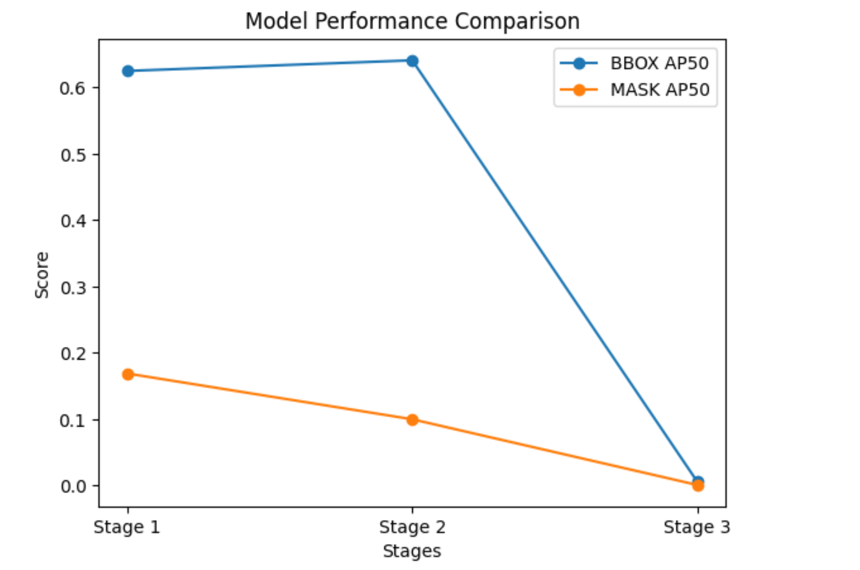

7.2 YOLO Results

7.2.1 Detection Performance
The YOLO segmentation model demonstrated superior detection performance. On the test dataset, the model achieved:
Bounding Box Precision ≈ 0.864
Bounding Box Recall ≈ 0.769
Bounding Box mAP@50 ≈ 0.854
Bounding Box mAP@50–95 ≈ 0.626
These results indicate a high level of accuracy in identifying and localizing cracks, even under stricter evaluation conditions.

7.2.2 Segmentation Performance
Segmentation results were significantly higher compared to Mask R-CNN:
Mask Precision ≈ 0.712
Mask Recall ≈ 0.639
Mask mAP@50 ≈ 0.572
Mask mAP@50–95 ≈ 0.214
The model demonstrated the ability to capture crack regions effectively, although performance decreased under stricter IoU thresholds.

7.2.3 Analysis of Results
The YOLO model showed:
- strong generalization (test performance slightly higher than validation)
- stable convergence during training
- effective use of transfer learning
However, segmentation performance remained lower than detection performance due to:
- difficulty in precisely delineating thin crack boundaries
- sensitivity to dataset complexity and annotation quality
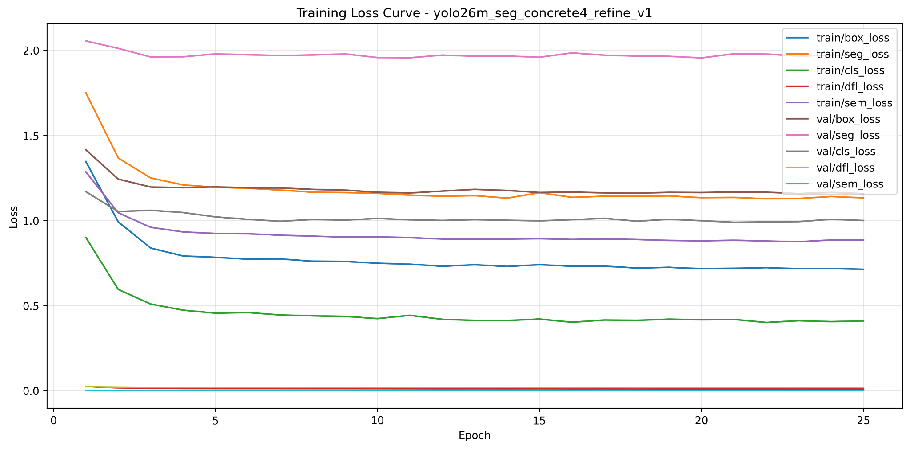
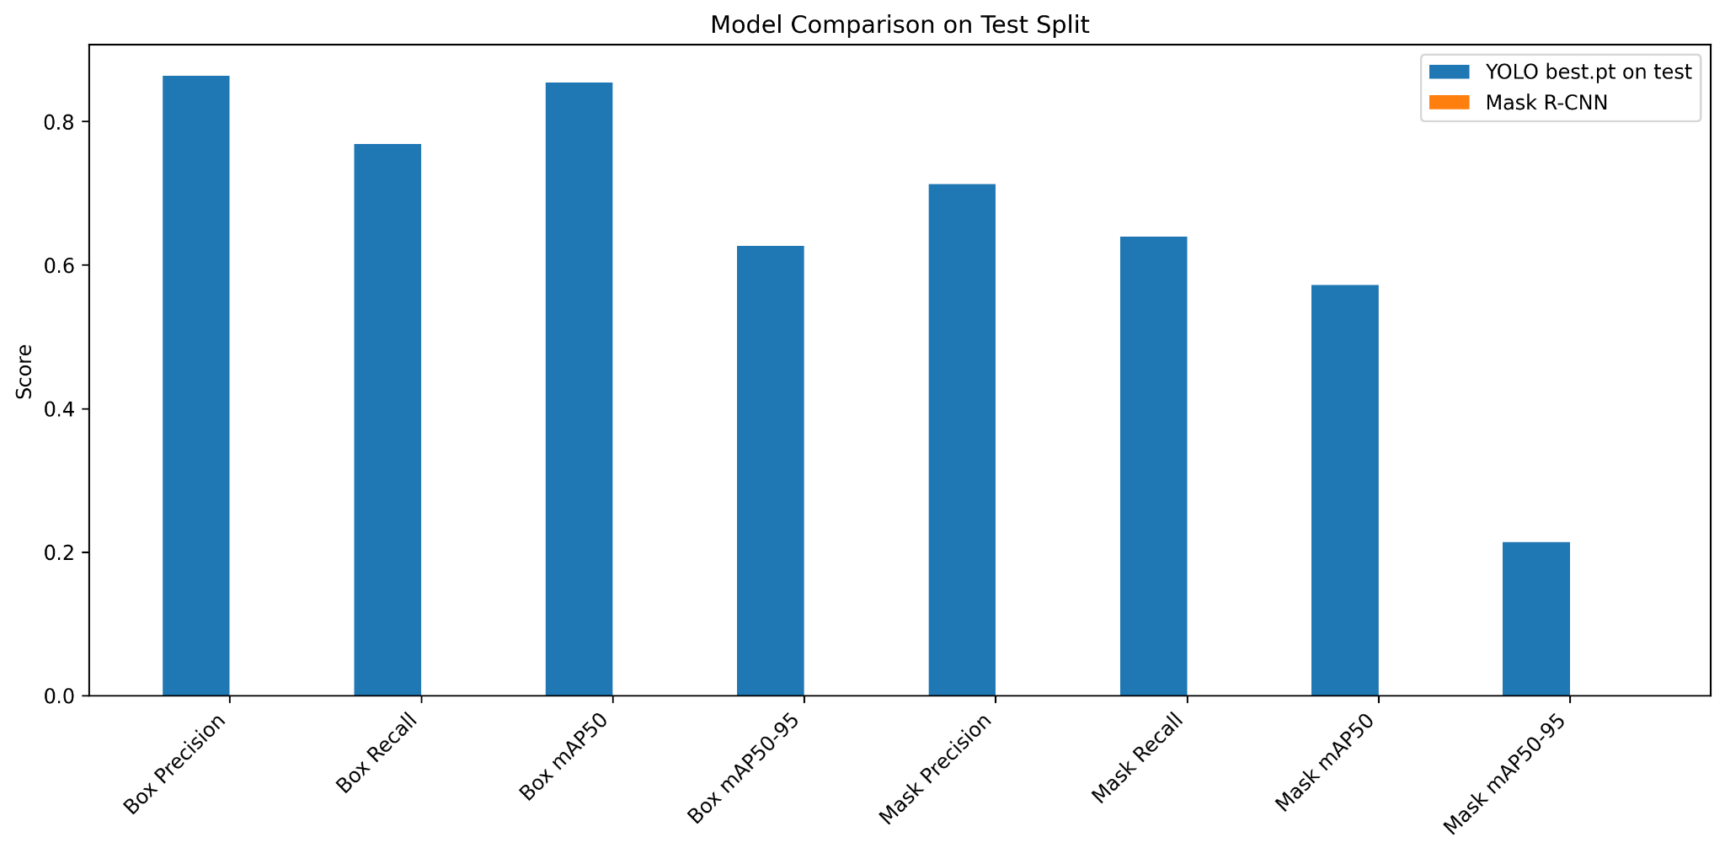
.

8. Comparative Analysis
A comparative evaluation will be conducted between Mask R-CNN and YOLOv26m-Seg based on:
- Accuracy (mAP, IoU)
- Training stability
- Inference speed
- Visual quality of segmentation
The goal is to determine:
Which model provides the best balance between accuracy and efficiency for crack detection.

8.1 Overview of Models
This study evaluates two state-of-the-art deep learning approaches for crack detection and segmentation:
- Mask R-CNN: a two-stage detector designed for precise object localization and pixel-level segmentation
- YOLO (YOLO26m-seg): a one-stage model optimized for fast detection with integrated segmentation
Mask R-CNN emphasizes accuracy and structural understanding, while YOLO focuses on speed and efficiency.

8.2. Quantitative Comparison

Detection Performance (Bounding Boxes)
Model | mAP@50 (BBOX) | mAP@50–95
Mask R-CNN | ~0.64 | ~0.35
YOLO | 0.854 | 0.626
YOLO significantly outperforms Mask R-CNN in detection.

Segmentation Performance (Masks)
Model | mAP@50 (MASK) | mAP@50–95
Mask R-CNN | ~0.10–0.18 | very low
YOLO | 0.572 | 0.214
YOLO also outperforms Mask R-CNN in segmentation.

8.3. Detection Capability Analysis
YOLO demonstrates superior detection performance:
- High precision (≈ 0.86) and recall (≈ 0.77)
- Strong localization even under stricter IoU thresholds
- Robust generalization across validation and test datasets
In contrast, Mask R-CNN achieved:
- Reliable detection (mAP@50 ≈ 0.64)
- Slightly lower robustness under stricter evaluation metrics

Interpretation
YOLO provides stronger and more consistent crack localization,
making it more suitable for detection-focused applications.

8.4. Segmentation Performance Analysis
Both models show a gap between detection and segmentation performance, but the gap is smaller for YOLO.

YOLO:
- mAP@50 ≈ 0.57
- Better mask precision and recall
- More consistent segmentation across datasets

Mask R-CNN:
- mAP@50 ≈ 0.10–0.18
- Struggles with fine crack boundaries
- More sensitive to annotation quality

Key Insight
YOLO captures crack regions more effectively,
while Mask R-CNN struggles with thin and irregular structures.

8.5. Training Behavior and Convergence

YOLO:
- Stable convergence across epochs
- Effective transfer learning using pretrained weights
- Strong performance even with limited training epochs
- Good generalization (test > validation performance)

Mask R-CNN:
- Gradual improvement across stages
- Requires careful tuning and staged training
- Sensitive to fine-tuning strategy
- Early stopping necessary to avoid overfitting

8.6. Generalization Performance
YOLO showed:
- Slightly higher performance on test set than validation
- Strong generalization capability
Mask R-CNN showed:
- Stable but lower overall performance
- More sensitivity to dataset variations

8.7. Computational Efficiency
Model | Speed | Complexity
Mask R-CNN | Slow | High
YOLO | Fast | Moderate
YOLO is significantly faster due to its single-stage architecture.

8.8. Strengths and Weaknesses

Mask R-CNN
Strengths:
- Strong structural understanding
- Accurate bounding box localization
- Flexible segmentation framework
Weaknesses:
- Lower segmentation accuracy for thin cracks
- Slower inference
- Sensitive to training strategy

YOLO
Strengths:
- High detection accuracy
- Faster inference
- Better segmentation performance
- Strong generalization
Weaknesses:
- Slightly less precise boundary delineation under strict IoU
- May produce false positives in noisy textures

8.9 Comparative Results Summary
Metric | Mak R-CNN | YOLO26m-seg
BBOX mAP@50 | 0.64 | 0.854
BBOX mAP@50-95 | 0.35 | 0.626
MASK mAP@50 | ~0.10-0.18 | 0.572
mask mAP@50-95 | Very low | 0.214

9. Limitations

Despite the promising results achieved using both Mask R-CNN and YOLO, several limitations were identified that impact the overall performance and generalizability of the models.

9.1. Difficulty in Segmenting Thin Crack Structures

A major limitation observed in both models is the challenge of accurately segmenting cracks due to their:

thin and elongated geometry

irregular and fragmented patterns

low contrast with surrounding surfaces

These characteristics make segmentation highly sensitive to small spatial errors, resulting in reduced mask accuracy under IoU-based evaluation metrics.

2. Dependence on Annotation Quality

The performance of both models, particularly in segmentation tasks, is strongly dependent on the quality and consistency of annotations. Variations in:

mask thickness

boundary precision

labeling consistency

can negatively affect model learning and lead to suboptimal segmentation results.

3. Resolution Constraints

Both models operate on resized inputs, which may lead to:

loss of fine crack details

reduced boundary precision in segmentation outputs

This limitation is especially significant for high-resolution crack patterns, where subtle features are critical for accurate delineation.

4. Model-Specific Limitations

Mask R-CNN:

Slower inference speed due to its two-stage architecture

Lower segmentation performance for thin structures

Increased computational complexity

YOLO:

Slightly less precise boundary delineation under strict IoU thresholds

Potential for false positives in complex or textured backgrounds

5. Limited Generalization Across Diverse Conditions

Although YOLO demonstrated good generalization within the dataset, both models may face challenges when applied to:

different lighting conditions

varying surface textures

unseen crack types

This highlights the need for more diverse and representative datasets.

10 Future Enhancements

To address the identified limitations and further improve model performance, several enhancements are proposed.

1. Improved Annotation Quality

Enhancing the precision and consistency of annotations can significantly improve segmentation performance. Future work should focus on:

generating thinner and more accurate masks

ensuring consistent labeling across datasets

using semi-automated annotation tools for refinement

2. Higher Resolution Training

Training models on higher-resolution images (e.g., 800×800 or 1024×1024) can:

preserve fine crack details

improve boundary accuracy

enhance segmentation performance

3. Advanced Data Augmentation

Applying more sophisticated augmentation techniques such as:

geometric transformations

contrast adjustments

noise injection

can improve model robustness and generalization to real-world conditions.

4. Model Optimization and Hybrid Approaches

Future research could explore:

combining detection strengths of YOLO with segmentation capabilities of Mask R-CNN

integrating attention mechanisms to improve feature extraction

experimenting with newer architectures designed for thin-object segmentation

5. Loss Function Optimization

Adjusting loss functions to emphasize segmentation accuracy, such as:

increasing mask loss weighting

incorporating boundary-aware loss functions

may improve the model’s ability to capture fine crack structures.

6. Real-Time Deployment and Optimization

For practical applications, future work may include:

optimizing YOLO for edge devices

reducing model size and inference latency

deploying models in real-time monitoring systems

7. Dataset Expansion

Expanding the dataset to include:

diverse crack types

varying environmental conditions

different materials and surfaces

will improve model generalization and robustness.

11. Conclusion
This study presented a comparative analysis of Mask R-CNN and YOLO for automated crack detection and segmentation in concrete structures.
The results demonstrate that both models are capable of effectively identifying crack regions; however, their performance differs significantly in terms of accuracy, efficiency, and robustness.
Mask R-CNN showed strong and consistent performance in object detection, achieving reliable localization of cracks across different datasets. Its two-stage architecture enabled structured feature learning and stable convergence during training. However, its segmentation performance was comparatively limited, particularly for thin and irregular crack patterns, where small boundary deviations significantly impacted IoU-based evaluation metrics.
In contrast, YOLO exhibited superior performance across both detection and segmentation tasks. The model achieved higher precision, recall, and mean average precision scores, indicating more accurate and consistent predictions. Additionally, YOLO demonstrated faster convergence, better generalization to unseen data, and significantly improved computational efficiency due to its single-stage design. These characteristics make it highly suitable for real-time and large-scale applications.
A key observation from this study is that crack segmentation remains inherently challenging for both models due to the fine-grained and irregular nature of crack structures. Despite this, YOLO was better able to capture crack regions and produce more consistent segmentation outputs, while Mask R-CNN struggled to achieve precise boundary delineation.
Overall, YOLO emerged as the more effective model for this task, offering a better balance between detection accuracy, segmentation quality, and computational efficiency. Mask R-CNN, while robust and reliable for localization, is less suited for high-precision crack segmentation under the given conditions.
In conclusion, for practical crack detection systems where both accuracy and efficiency are critical, YOLO provides a more suitable solution. Future work may focus on improving segmentation performance through higher-resolution inputs, enhanced annotation quality, or hybrid approaches that combine the strengths of both architectures.

